PABALLO MARY MOKOENA

MODUDLE NAME: WED DEVELOPMENTSTUDENT NO:ST10501151GROUP ONEDNM0601WEB DEVELOPMENT PROPOSAL
  - [Document subtitle]

Table of Content
Contents
3. Content Research and Sourcing- Pabii’s Retreat 2
Project Description 2
3.1 Organisation Overview 2
The website will therefore contain the following main pages: 2
Website Structure and Planning 3
4.1 Sitemap- Pabii’s Retreat 3
Pabii’s Retreat website will use the following structure. 3
KEY Features and Functionality 4
PABII’S RETREAT PAGES 4
1.Homepage-indx.html 4
2.About Us-about.html 4
3.Services/ Packages- services.html 5
4. Package Details- packages.html 6
5. Gallery- gallery.html 6
6. Enquiry- enquiry.html 7
7. Contact Us – contact.html 7
8. Customer Reviews- reviews.html 8
9. Social media 9
Content Research and Sourcing 9
Timeline and Milestones 9
Part 1 Details 9
Future Improvements 9
Part 2 Details (CSS and Responsive Design) 10
Part 1 Feedback Implementation and Corrections 11
Part 2 Feature Additions (CSS and Responsive Design) 11
References 12

README.md link: https://github.com/Pabii96/Pabii-Retreat---.git

3. Content Research and Sourcing- Pabii’s Retreat

Project Description
Pabii’s Retreat is a wellness and massage website that is designed to provide customers/clients useful information about the business, available services we offer, packages we have, gallery, customer review. Enquires and contact details.

3.1 Organisation Overview
Pabii’s Retreat wad founded by Paballo in July 2026, was created and dedicated with the vision of helping clients to restore their balance, relieve stress and improve their overall health. It was established to deliver the needs of clients after the recognition that a lot of people suffer from stress, fatigue, muscle tension and the pressure of life. The Retreat will ensure that it offers different range of therapeutic services that will includes hot stone therapy, facial treatment, Swedish massage, full body massage and more.
Main reason of establishing Pabii’s Retreat was to provide affordable, high-quality services to motivate people to prioritise their health, promote their physical and mental wellness in a calm and comfortable environment.

The website will therefore contain the following main pages:
- Homepage
- About Us
- Services
- Packages
- Gallery
- Customer Reviews
- Enquiries
- Contact Us

Website Structure and Planning

4.1 Sitemap- Pabii’s Retreat
- The Retreat sitemap provides visitors will access to information about the organization, wellness services, the packages, gallery, enquiries, customer reviews and contact information.
- The provided structure helps customers find suitable treatments, be able to have a refreshing environment and make enquiries or spa bookings efficiently.

Pabii’s Retreat website will use the following structure.

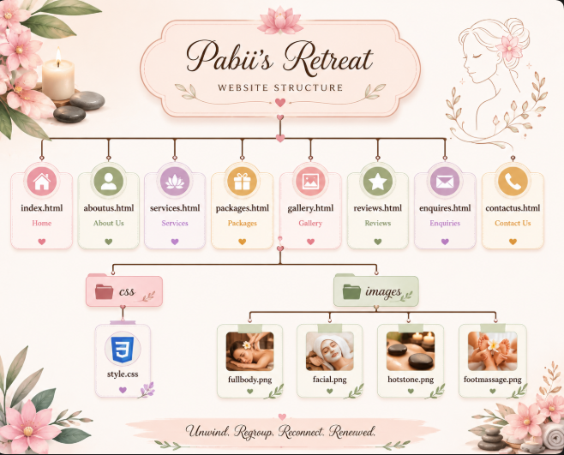
Figure 1 image created in Canva

KEY Features and Functionality
- Multi-Page Structure: Dedicated pages for Home, About Us, Services, Package, Gallery, Customer Review, Enquiries, and Contact Us.
- Responsive Layout: Adaptive desktop, tablet, and mobile layouts built on CSS Grid, and media queries.
- Interactive Forms: Functional enquiry form with deposit/booking policy details and a direct contact form.
- CSS Visual Styling: Modern aesthetic featuring a custom colour scheme, typograph scales, pseudo-class (; hover,: focus, :active).

PABII’S RETREAT PAGES

1.Homepage-indx.html
Welcome to Pabii’s Retreat
- Unwind. Regroup. Reconnect. Renewed
Our retreat spa offers personalized treatment and therapeutic treatment for its customers to able to unwind, calm their minds, relax the bodies, be flexible and mostly have a healthy lifestyle.

2.About Us-about.html
Pabii’s Retreat is a customised spa and therapeutic treatment that provides its clients a personalised wellness experience that is designed to remove them from everyday life and promotes relaxation and improving long lasting wellness.
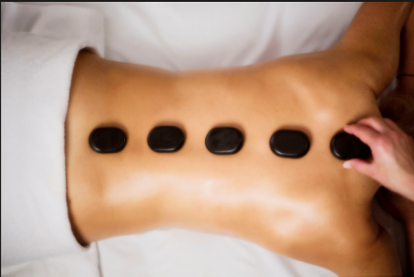
Figure 2 taken from google

Mission
We aim to provide exceptional and personalised therapy that calms the mind, relax the body, lift the spirit and mostly creating a lasting sense of well-being to our clients.
Vision
Our aim is to become a respected, leading and reputable centre of excellence by providing high-quality relaxation and therapeutic services.

3.Services/ Packages- services.html
Packages include
- Welcome juice
- 45 mins Full Body Massage
- Lunch and coffee/juice all this luxury for R600.
- Welcome juice
- Facial Treatment for R200
- 30 mins Full Body Massage
- 15 mins backstone therapy
- 15 mins facial treatment all for R350
NB-And additional services to offer

4. Package Details- packages.html
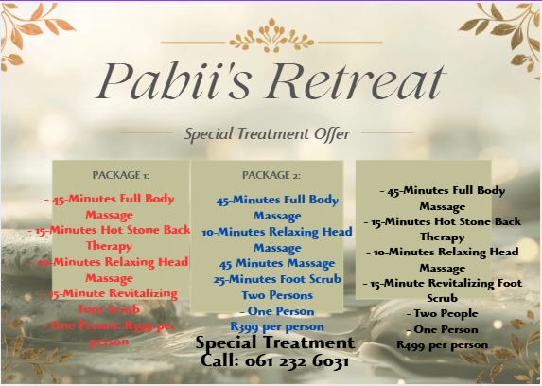
Figure 3 Image created on Canva

5. Gallery- gallery.html
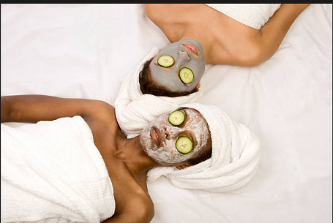
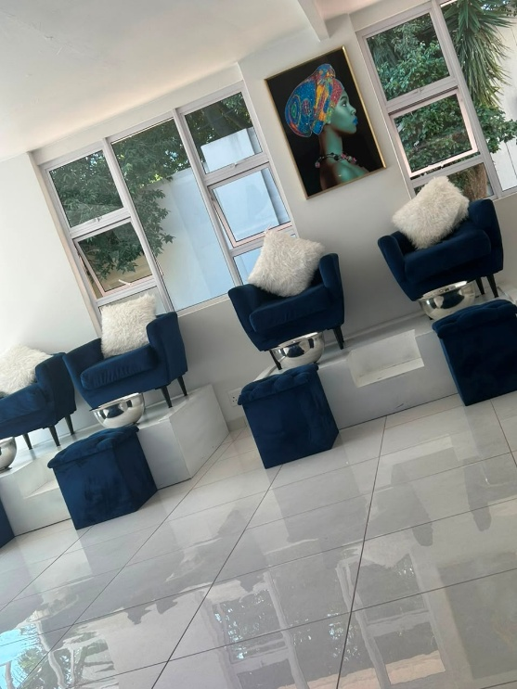
Figure 4 taken from google
Figure 5 Pabi, taken by phone

6. Enquiry- enquiry.html
Complete the form below to enquire about our services or request a spa appointment. Our team will respond with availability and further information.
- Booking Policies: Required non-refundable deposit of 30% to confirm your appointment
- Late fee required after 30 minutes grace period.
Enquiry form
Personal information:
- Full Name
- Email Address
- Phone Number
Appointment information:
- Preferred Date
- Preferred Time
- Preferred Treatment
- Number of People
Additional requirements:
- Special requests
- Questions
- Preferred therapist, if applicable

7. Contact Us – contact.html
Information to include
- Phone:
061 232 6031
- Email:
pabii’s@retreatspa.co.za
Address:
195/11907 Msilinga Street
Pimville Zone 9
1809
- Business hours:
Monday- Friday-9am- 6pm
- Saturday-8am- 1pm
- Sundays closed
- Public holidays open upon request
Contact form
- Full Name
- Email
- Phone
- Subject
- Message
- Submit button

Location
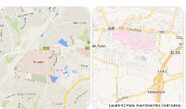

8. Customer Reviews- reviews.html
As Pabii’s Retreat is a new business that started operating in July, it doesn’t currently have an existing customer review yet as we are still promoting the business using family and friends.

9. Social media
As Pabii’s Retreat is a newly formed business it hasn’t yet established social media yet as it was launched in July 2026. Social media has been spoken about as any important marketing platform. This social media platform will assist in promoting the business.

Content Research and Sourcing
- Organisation’s Website (if applicable)
Pabii’s Retreat was established in July 2026 as a new business, it currently has limited existing as we were using WhatsApp to promote the business to our friends, family and close neighbours. The proposed websites will be established to attract customers and provide them with important information about the Retreat.
- Social Media:
As Pabii’s Retreat is a newly formed business it hasn’t yet established social media yet as it was launched in July 2026. Social media has been spoken about as any important marketing platform. This social media platform will assist in promoting the business
- Public Domain and Creative Commons Resources: Pabii’s Retreat will use public domain and creative that will be suitable for the organization that will display resources such as wellness, nature etc.

Timeline and Milestones
- Phase 1: Research, Sitemap Planning, and Proposal Submission.
- Phase 2: HTML Structure Implementation and GitHub Version Control.
- Phase 3: CSS Styling, Responsive Design, and Testing.

Part 1 Details
- Initial Sitemap creation and content research complete.
- Basic HTML structure set up across main pages.
- Repository set up and initials files committed.

Future Improvements
Future improvements to the website may include:
- Implementing customer reviews and testimonials page.
- Adding social media links.
- Improving by implementing an online booking system.
- Showcase more treatment photographs.
- Having more package options.
- Improving accessibility and mobile responsiveness.
- Introducing an online payment option.
- Updating services and prices when required.

Part 2 Details (CSS and Responsive Design)
- External Stylesheet: Styled using css/style.css with baseline typography, custom colour palette, and CSS reset rules.
- Layout Techniques: Flexible layout structures implemented using CSS Grid for multi-column alignment.
- Breakpoints and Media Queries: Customized media queries targeting desktop, tablet and mobile viewpoints.
Responsive Design Evidence
Desktop View, Tablet view and Mobile view

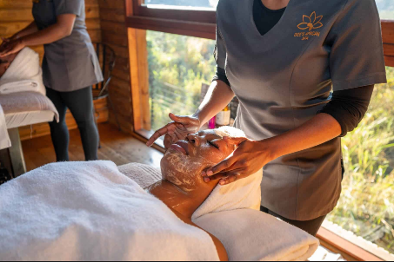

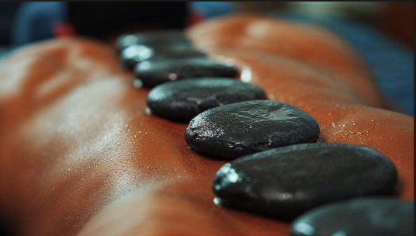

Part 1 Feedback Implementation and Corrections
- (09 September 2026): HTML file Paths- Corrected file naming and relative link paths across all navigation menus to ensure seamless page transitions.
- (11 September 2026): Semantic Markup- Updated HTML structure to include semantic layout elements (<header>, <nav>, <main>, <sections>, and <footer>.
- (12 September 2026): Form Controls- Added appropriate field for both the enquiry form and contact us.

Part 2 Feature Additions (CSS and Responsive Design)
- (14 September 2026): Stylesheet Integration- Created external stylesheet css/style.css and linked all pages.
- (14 September 2026): Base styling and Typography- Define typography scaling (rem/ em), baseline margins, paddings, and CSS reset.
- (15 September 2026): Layout Implementation- Built multi-column cards layouts using CSS Grid for desktop screens.
- (16 September 2026): Media Queries- Added responsive breakpoints converting desktop grid layouts into a single-column flow for tablet and mobile devices.
- (16 September 2026): Interactive States- Added hover and active focus to buttons, navigation elements and form inputs.

References
American Massage Therapy Association (AMTA), 2024. Massage Therapy Research and Consumer Information. [Online]. Available at:< https://www.amtamassage.org/> [Accessed 25 July 2026].
https://www.bing.com/images/search?view=detailV2&ccid=t5qfgs8o&id=2F61F93ECF7D69BB6E024EE84627149EA7F2CA9D&thid=OIP.t5qfgs8omEmCWekZPefCBwHaEO&mediaurl=https%3A%2F%2Faromatherapynaturals.com%2Fwp-content%2Fuploads%2F2024%2F12%2Felevate_your_massage_experience.jpg&cdnurl=https%3A%2F%2Fth.bing.com%2Fth%2Fid%2FR.b79a9f82cf2898498259e9193de7c207%3Frik%3Dncryp54UJ0boTg%26pid%3DImgRaw%26r%3D0&exph=575&expw=1006&q=aromatherapy+massage+-+Search+Images&ck=E7C2BFA8A1C75596C438E7D4141545B4&selectedIndex=55&itb=0&ajaxhist=0&ajaxserp=0&shtc=0&shth=OIP.t5qfgs8omEmCWekZPefCBwHaEO&shsc=idp&form=EX0050&shid=ff5e0333-9973-4d1d-aa0e-1f9378f8cd1d&shtp=GetUrl&shtk=MTMgQmVzdCBFc3NlbnRpYWwgT2lscyBmb3IgTWFzc2FnZTogRWxldmF0ZSBZb3VyIFJlbGF4YXRpb24gR2FtZSAuLi4%3D&shdk=Rm91bmQgb24gQmluZyBmcm9tIGFyb21hdGhlcmFweW5hdHVyYWxzLmNvbQ%3D%3D&shhk=u6az3ROlUdNxkLzwUIAxR3Htfwcm94wDjjqLp64IhoI%3D
https://www.bing.com/images/search?view=detailV2&ccid=lx%2BuD3d5&id=D1E178B6622948EBA07401C7A2ADC387C5F81AD2&thid=OIP.lx-uD3d5dLHkoUpmfAMu3AHaE8&mediaurl=https%3A%2F%2Fhealthclub-esplanade.com%2Fwp-content%2Fuploads%2F2019%2F01%2F8.-Hot-stone-ROTIRANA.jpg&cdnurl=https%3A%2F%2Fth.bing.com%2Fth%2Fid%2FR.971fae0f777974b1e4a14a667c032edc%3Frik%3D0hr4xYfDraLHAQ%26pid%3DImgRaw%26r%3D0&exph=1280&expw=1920&q=+body+massage+stone+-+Search+Images&ck=EF2118595807400607DAB96ED8B1A42A&selectedIndex=4&itb=0&ajaxhist=0&ajaxserp=0&shtc=0&shth=OIP.lx-uD3d5dLHkoUpmfAMu3AHaE8&shsc=idp&form=EX0050&shid=bde50b97-aa29-4ab7-9779-298ba9980030&shtp=GetUrl&shtk=SG93IFRvIFBlcmZvcm0gSG90IFN0b25lIE1hc3NhZ2UgYXQgUm9iYmluIFdvb2QgYmxvZw%3D%3D&shdk=Rm91bmQgb24gQmluZyBmcm9tIHN0b3JhZ2UuZ29vZ2xlYXBpcy5jb20%3D&shhk=ao%2F4E7%2FfRqCjeFCp5ERwc%2FIqBv1SujO34Z2o9bEEdC8%3D
Creative Commons, 2026. Sharing openly, sharing globally. [online] Available at: < Creative Commons – Sharing Openly, Sharing Globally> [Accessed 02 August 2026].
Creative Commons, 2026. Attribution. [online] Available at:< Creative Commons – Attribution> [Accessed 02 August 2026].
Sharpsheets, 2026. SWOT Analysis for a Massage Therapy Business. [Online]. Available at: <https://sharpsheets.io/blog/swot-analysis-massage-therapy-business/ >[Accessed 25 July 2026].
https://www.bing.com/images/search?view=detailV2&ccid=6%2BfBkPLC&id=439DE6E0277CD1442E7D56F30191E25E020C12CF&thid=OIP.6-fBkPLC794H0GBCB8hk0wHaE8&mediaurl=https%3A%2F%2Fimg.freepik.com%2Fpremium-photo%2Feditable-spa-business-logo-vector-with-balance-text_1254992-10025.jpg%3Fw%3D900&cdnurl=https%3A%2F%2Fth.bing.com%2Fth%2Fid%2FR.ebe7c190f2c2efde07d0604207c864d3%3Frik%3DzxIMAl7ikQHzVg%26pid%3DImgRaw%26r%3D0&exph=600&expw=900&q=+spa+parlour+logo+for+a+new+business+called+Pabii%27s+Retreat+-+Search&ck=E1B6643EE210B453261A080EF99E55F4&selectedIndex=1&itb=0&ajaxhist=0&ajaxserp=0&shtc=0&shth=OIP.6-fBkPLC794H0GBCB8hk0wHaE8&shsc=idp&form=EX0050&shid=48273dae-15cd-4908-9e95-61ba2e1d23c2&shtp=GetUrl&shtk=UHJlbWl1bSBQaG90byB8IEVkaXRhYmxlIHNwYSBidXNpbmVzcyBsb2dvIHZlY3RvciB3aXRoIHRoZSBiYWxhbmNlIHRleHQ%3D&shdk=Rm91bmQgb24gQmluZyBmcm9tIHd3dy5mcmVlcGlrLmNvbQ%3D%3D&shhk=NIpQso3z%2BaJuNwRaoX6O%2FcJRL3x6Ee9Gk4FnVD8Ew4Q%3D
https://www.bing.com/images/search?view=detailV2&ccid=NCrYGR8u&id=49E6D10AE02BC7F7E6ADBD866E4EAB095F54DB30&thid=OIP.NCrYGR8uV-McKmyyYkqbQQHaE8&mediaurl=https%3A%2F%2Fmedia.istockphoto.com%2Fphotos%2Fbeauty-treatment-spa-picture-id145163444%3Fk%3D20%26m%3D145163444%26s%3D612x612%26w%3D0%26h%3DLyEUbeMiy2WNTa9tE0aOdZsLDe7LnsNT1yDdHs9RTWs%3D&cdnurl=https%3A%2F%2Fth.bing.com%2Fth%2Fid%2FR.342ad8191f2e57e31c2a6cb2624a9b41%3Frik%3DMNtUXwmrTm6GvQ%26pid%3DImgRaw%26r%3D0&exph=408&expw=612&q=+spa+images+difference+treatment+black+african+-+Search+Images&ck=06CBB55D2E8228D21229DE4BE962A4A3&selectedIndex=12&itb=0&ajaxhist=0&ajaxserp=0&shtc=0&shth=OIP.NCrYGR8uV-McKmyyYkqbQQHaE8&shsc=idp&form=EX0050&shid=8ef4e8c2-69d0-4198-ade1-357f2fddea70&shtp=GetUrl&shtk=QWZyaWNhbiBFdGhuaWNpdHkgU3BhIFN0b2NrIFBob3RvcywgUGljdHVyZXMgJiBSb3lhbHR5LUZyZWUgSW1hZ2VzIC0gaVN0b2Nr&shdk=Rm91bmQgb24gQmluZyBmcm9tIHd3dy5pc3RvY2twaG90by5jb20%3D&shhk=auPxyXQGjQtjvUbkVVGZ5uezX1pd5Zgdx5m1ifK147s%3D
https://www.bing.com/images/search?view=detailV2&ccid=My%2FaeOx3&id=49090FDEA61845D7E1BB0B8814D63825B1000350&thid=OIP.My_aeOx396tLuZcwJzNd-wHaE7&mediaurl=https%3A%2F%2Fkrugergatehotel.com%2Fwp-content%2Fuploads%2F2024%2F09%2FDees-Spa-KML_1302-copy.jpg&cdnurl=https%3A%2F%2Fth.bing.com%2Fth%2Fid%2FR.332fda78ec77f7ab4bb9973027335dfb%3Frik%3DUAMAsSU41hSICw%26pid%3DImgRaw%26r%3D0&exph=1206&expw=1812&q=+types+of+spa+treatments+black+african%2C+facial%2Cfoot%2Cbody%2Cswidish+-+Search+Images&ck=52F83C5050DCDF00899CC083EDE25CF0&selectedIndex=14&itb=0&ajaxhist=0&ajaxserp=0&shtc=0&shth=OIP.My_aeOx396tLuZcwJzNd-wHaE7&shsc=idp&form=EX0050&shid=0b34f954-dda4-42ac-bad5-0c7f85c8b251&shtp=GetUrl&shtk=QWZyaWNhbiBTcGEgLSBLcnVnZXIgR2F0ZSBIb3RlbCAtIGx1eHVyeSBzYWZhcmkgZXhwZXJpZW5jZQ%3D%3D&shdk=Rm91bmQgb24gQmluZyBmcm9tIGtydWdlcmdhdGVob3RlbC5jb20%3D&shhk=0gWumpdvNEosEpPZl%2FEG83xLi%2F60jICh1AmACPhrGBw%3D
World Health Organization (WHO), 2026. Self-care for health and well-being. [online] Available at:< WHO – Self-care for health and well-being> [Accessed 02 August 2026].

README.md link: https://github.com/Pabii96/Pabii-Retreat---.git

